Experiment No. 05

nano pract5.c

CODE:
#include <stdio.h>
#include <unistd.h>
#include <sys/types.h>
int main(){
pid_t pid;
pid=fork();
if(pid<0){
printf("Fork failed\n");
}
else if(pid==0){
printf("Child Process\n");
printf("Child PID : %d\n",getpid());
printf("Parent PID : %d\n",getppid());
}
else{
printf("Parent Process\n");
printf("Parent PID : %d\n",getpid());
}
return 0;
}

Compile the program:
gcc pract5c -o pract5
Execute the program:
./pract5

OUTPUT:
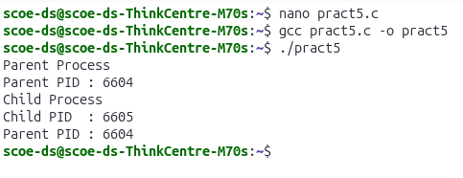
AIM
Create a child process in Linux using the fork system
call. From the child process obtain the process ID of
both child and parent by using getpid and getppid
system call.

RESOURCES REQUIRED
• Ubuntu Operating System
• Terminal
• Text Editor (nano)
• Sample text files

THEORY
In Linux, every running program is treated as a
process, and each process is uniquely identified by a
Process ID (PID). A new process can be created using
the fork() system call.
The fork() call duplicates the current process,
creating a child process. After execution of fork():
The parent process receives the PID of the child.
The child process receives 0.
Two important system calls used for identifying
processes are:
getpid() – returns the PID of the current process.
getppid() – returns the PID of the parent process.
Using these calls, the child process can display its
own PID and also the PID of its parent. This mechanism
is fundamental to multitasking operating systems and is
widely used in process manage.

Conclusion:
Thus, a child process was successfully created using
the fork() system call. The child process correctly
obtained its own process ID using getpid() and its
parent’s process ID using getppid(). This experiment
demonstrates basic process creation and identification

in Linux, providing practical understanding of
parent–child relationships in operating systems.
ment, scheduling, and
inter-process communication.

